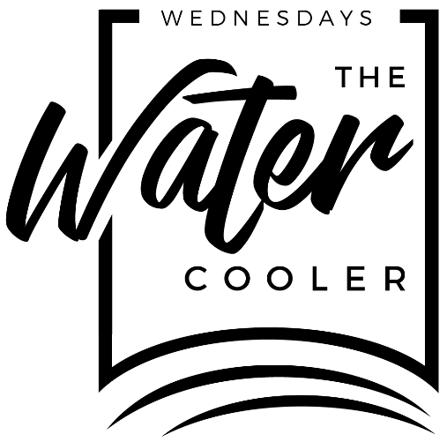

# Water Cooler Wednesday:

# 01-19-2022

# Capital Raise Discussion.

# 

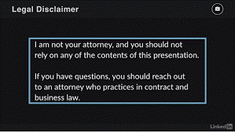

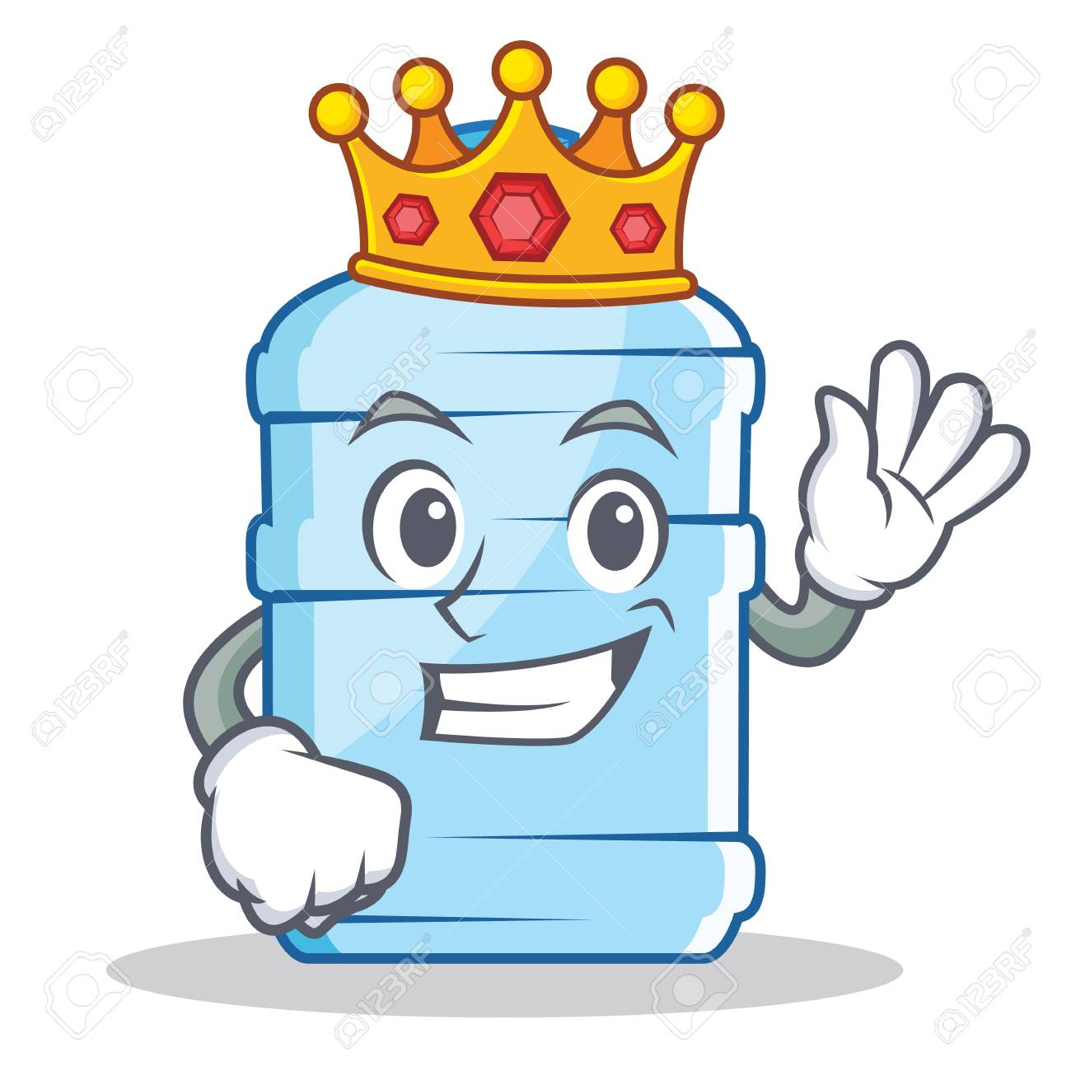

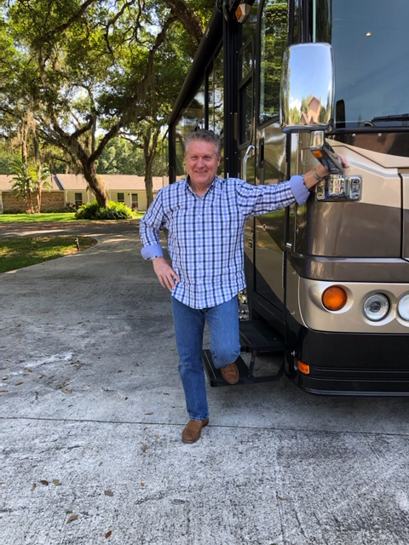

# Capital Raise Discussion.

# 

|  |  |  |  |
| --- | --- | --- | --- |
| |  |  |  | | --- | --- | --- | | |  |  | | --- | --- | | |  | | --- | |  | | | |

|  |  |  |
| --- | --- | --- |
| |  |  | | --- | --- | | |  | | --- | |  |  |   No photo description available.  Image may contain: 1 person, smiling |