Topics Covered Today:

Garnett Sailor

Richard Cullen

Social Media
Upcoming 3-day classes

Garnett Sailor

Can you point me to the reference in the Dodd Frank Act that says an investor selling to a consumer needs to use a licensed MLO? I've searched and searched the actual act and cannot find it.

Thanks

Richard Cullend: 1814 Walnut Ave., Anniston AL 36201

I now have a bid for the foreclosure property at 1814 Walnut Ave and would like some suggestions for work out strategies. I am running out of capital and would like advice on any possible exit strategies. I have received one written bid for about $54,000 to get the property to rental standards. A second contractor gave an estimate for about $50,000.

I currently have $12,500 invested in this property and have title. I think the value of the house is between $30,000 and $40,000. I obtained these values through comps from a real estate agent.

For the “Daily Deals”
Facebook: https://www.facebook.com/NotesDirect/
Twitter: @NotesDirect

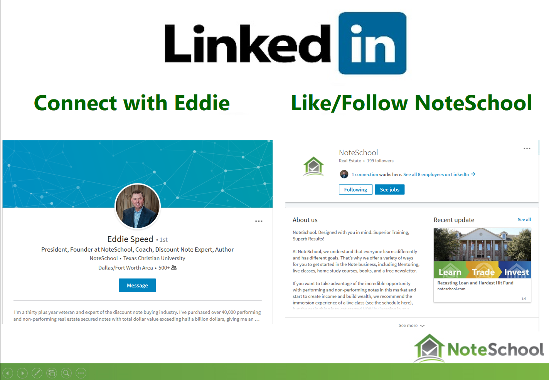

Upcoming 3-Day Classes

Denver, CO December 1st – 3rd

Phoenix, AZ December 8th-10th

New DropBox for Content Docs Submissions

https://www.dropbox.com/request/Enk7QksdLwgqXgVMK2Bz

New email for closing issues (Includes requests for any missing executed post-closing docs)

PostClosing@ColonialFundingGroup.com

If you want to Purchase Assets from the call: Offering@ ColonialFundingGroup.com

Please Submit Questions to: Content@NoteSchool.com

To Buy a Partial Contact Martha Speed at Martha@NoteSchool.com

