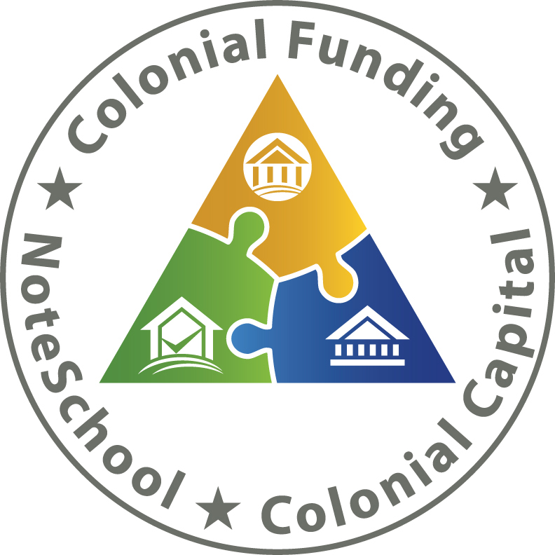

Topics Covered Today:

Market Conditions

NPL

Upcoming 3-day classes

2017 Titanium Office Visits

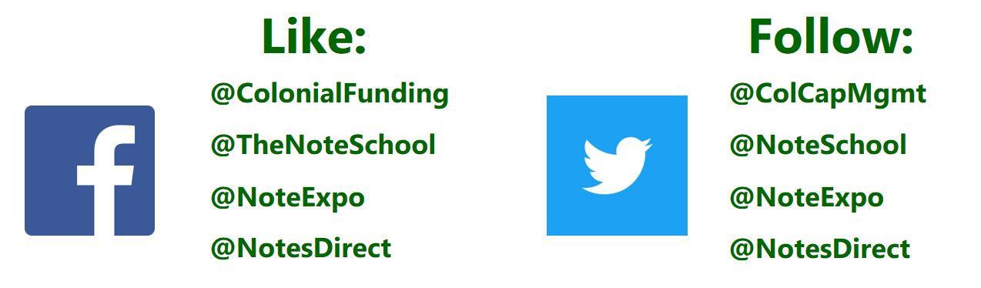

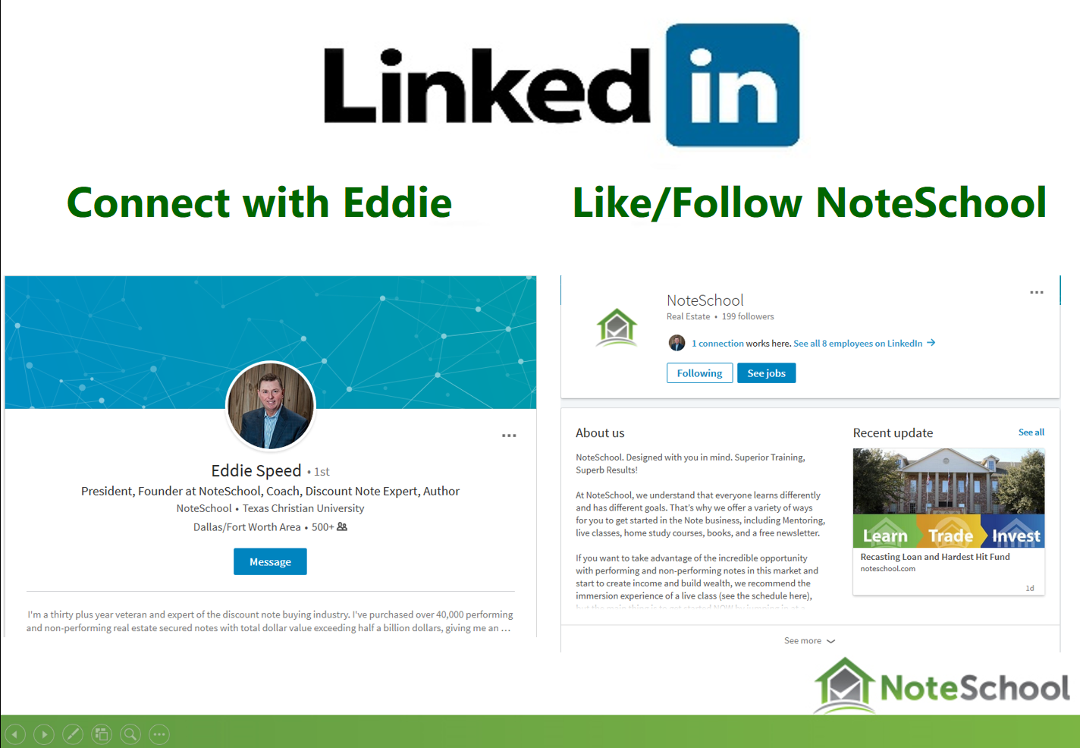

6th Annual Appreciation Event & Noteschool Expo
NOVEMBER 2nd - 4th

http://noteschool.com/6th-annual-appreciation-event/

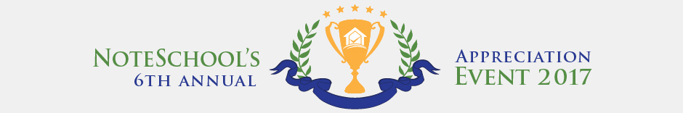

CASE STUDY COMPETETION
To Enter
http://members.noteschool.com/case-studies/

Upcoming 3-Day Classes

Pittsburg, Pennsylvania September 22nd – 24th

Nashville, Tennessee October 6th – 8th

Dallas, TX October 13th – 15th

Seattle, WA October 27th – 29th

2017 Titanium Visits

Titanium Office Visit – September 25th – 27th

DropBox for Content Docs Submissions

https://www.dropbox.com/request/Enk7QksdLwgqXgVMK2Bz

Email for closing issues (Includes requests for any missing executed post-closing docs)

PostClosing@ColonialFundingGroup.com

If you want to Purchase Assets from the call: Offering@ ColonialFundingGroup.com

Please Submit Questions to: Content@NoteSchool.com

To Buy a Partial Contact Martha Speed at Martha@NoteSchool.com

