Topics Covered Today:

Kevin Moen

Tyra Bacon

Keith Pionk

Upcoming 3-day classes

2017 Titanium Office Visits

Kevin Moen

I found a couple who are willing to seller finance me their duplex, I would live in one side and rent the other, its currently fully occupied, and way under market rent. Here is what we have discussed so far:
$325,000 purchase price
$5,000 down
5% interest rate
Amortized over 30 years
10 year balloon

Property address:
2907 NE 6th St
Renton, WA 98056

They currently rent each side for $900, market rents are closer to $1400 (being somewhat conservative) with minimal upgrades. The units are dated, I would slowing fix up my half, and address the other side whenever that tenant moved out.
They have a 1st against the property, but mentioned to me today they are considering paying that off with an inheritance they are receiving. So I am going into this with the assumption this will be free and clear prior to closing.
When I look at a deal like this (and in this crazy market) I try to ensure I cash flow at least $300/mo after PITI, repair allowance, utilities, and vacancy.
Here are what the numbers look like under the normal amortization and math:
Here is what they look like if we pay a flat $1400/mo to the seller:
My questions:
- Would you structure this as a land contract or note and mortgage?
- What is the most clean way to purchase under the assumptions above, yet pay $1400/mo to the seller?
-> How would that amortization table look, and payoff amount be determined?
- Would you recommend doing a combo of first and second to get the payments right and keep the deal clean? Maybe a second with no payments, and a first designed to hit that $1400/mo?
- If I am trying to keep debt off my personal profile, is a land contract a better tool for this?

Tyra Bacon

I am considering purchasing asset #56576. When I run amortization schedules based on the 2nd loan modification, the unpaid balance should be $55,097.26 with 209 payments remaining. The information provided shows the unpaid balance as $51,978.74 with 194 payments remaining. How would I go about reconciling the difference and how concerned should I be about it?

There was a HAMP modification with a schedule of increasing interest rates and payments over time. I don’t know how to reconcile the difference. I wonder if there was an error on the servicer’s part. The principal is $3100 less than expected, the remaining payments are less than expected and at the same time it appears the borrower is behind 7 payments. What do I do with this?

Keith Pionk

The questions are
- Schedule A..exempt's a Mortgage of 25k from the same lender, dated the same as the mortgage I am buying. At first look, this appears to be the FIRST and I would have a second. Your thoughts??
- The MOD (it is not attached) provides a page for the Lender to execute, But they did not execute it.. Does the MOD need to be signed by the Lender??
- The Note has TWO endorsement, stamped on the last page. One was left blank for the PAY TO THE OF:...there is an allonge to my seller after that. Does this present an issue?? The AOM change is good, I have attached it for your review.

So, I ordered Title work to make sure of the change of title. I hope to have it back before the call.

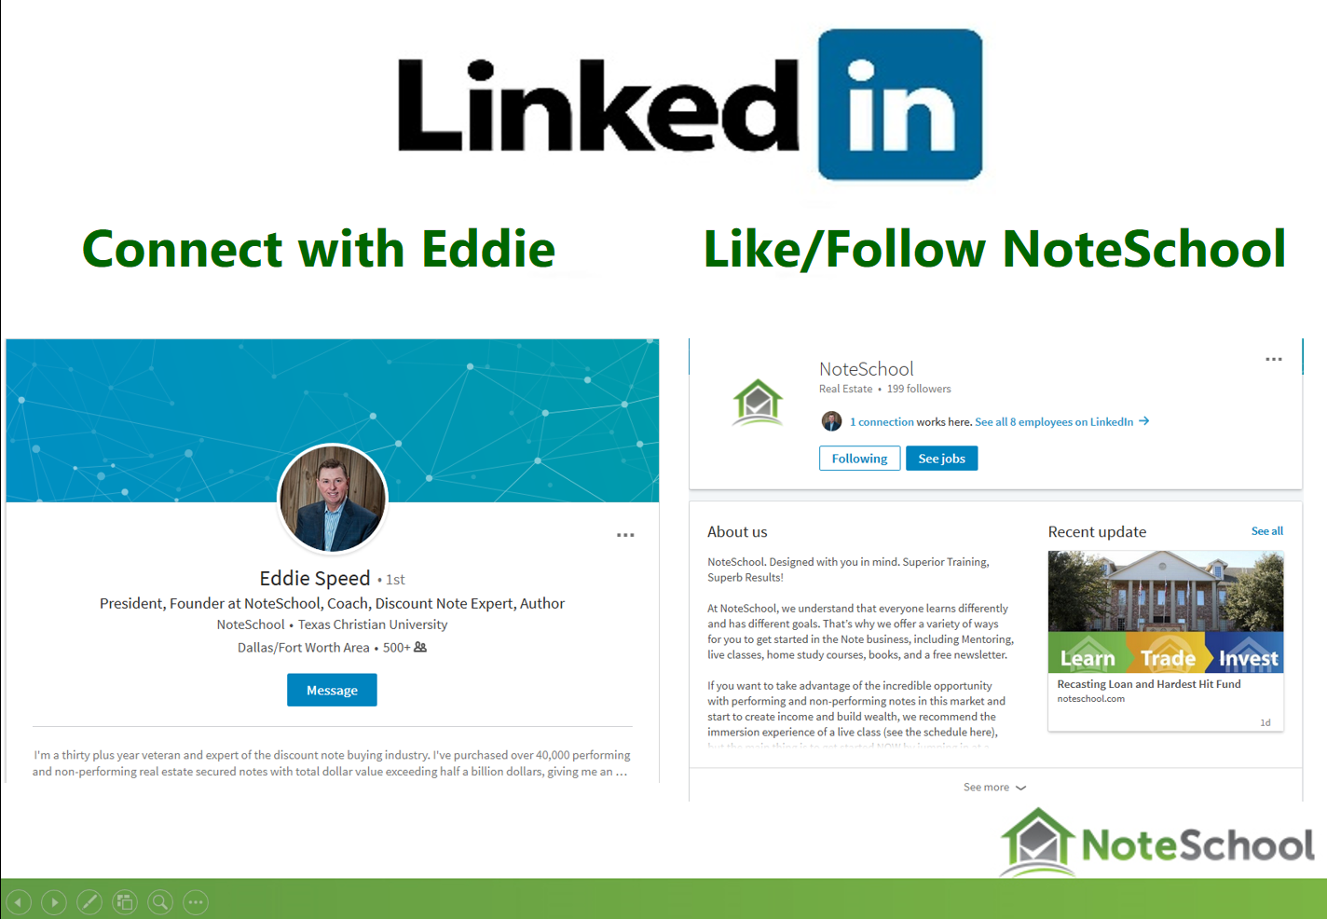

6th Annual Appreciation Event & Noteschool Expo
NOVEMBER 2nd - 4th

Upcoming 3-Day Classes

Pittsburg, Pennsylvania September 22nd – 24th

Nashville, Tennessee October 6th – 8th

Dallas, TX October 13th – 15th

Seattle, WA October 27th – 29th

2017 Titanium Visits

Titanium Office Visit – September 25th – 27th

New DropBox for Content Docs Submissions

https://www.dropbox.com/request/Enk7QksdLwgqXgVMK2Bz

New email for closing issues (Includes requests for any missing executed post-closing docs)

PostClosing@ColonialFundingGroup.com

If you want to Purchase Assets from the call: Offering@ ColonialFundingGroup.com

Please Submit Questions to: Content@NoteSchool.com

To Buy a Partial Contact Martha Speed at Martha@NoteSchool.com

