

# Topics Covered:

# Dave F: Defaulting Hard Money Loan

# Open Mic

# Kevin M: Defaulting Partial

**2017 Titanium Office Visits  
Summer Summit**

**DS News Article**

* Origination date  7/16
* Orig UPB  $140000 + 3 Pts = $144000++
* Rate   11%
* Balloon   12/8/16
* Rate now 24%
* Personal guarantee of payor on the assisted living home with a UCC agreement
* Commercial appraisal of $400,000
* State supported income

Jeff Watson recommended a Cleveland attorney whom I contacted. Jeff also drafted the original docs.

Balloon due December 8, 2016

Financiers trying to fix and flip 3 other properties

Out of country financier from China in London

**Dave Franecki**

I have a good case study for a partial that has stopped paying.

I sold an investor a partial that we both knew was semi performing, but I gave them a huge yield, and I recovered my investment through the partial sale, pretty much broke even.

Now that the note has stopped paying, and is fully non performing, the servicer is sticking me with the servicing fees, and foreclosure fee since we are going through the servicer for foreclosure. The servicer suggested getting a side agreement with the partial buyer to have him reimburse me for servicing and foreclosure fees. I have not approached him yet until I have a better plan with a few options for us to discuss.

I am trying to determine if I should cash out my investor and take over, or maybe propose to partner on this REO in some capacity after foreclosure.

The investor bought this in his IRA, Jeff Watson told me I would have to cash them out with IRA money which I am not in a position to do. I may have to find an investor to buy this note from him and partner through to an exit. Not sure the best way to go about that.

The numbers:

$25,000 rough amount to cash partial owner out

$20,000 SWAG repair estimate

$  5,000 back tax estimate

$50,000 to get to rental condition (rough number)

I am not sure if the borrower lives there, or if its vacant. I would love to purse HHF but the borrower has not responded to communication in months. 50/50 seems like a good model on paper, but I am worried about the super high crime, and terrible school rating on the RISK report turning investors off. Not to mention Gary, IN has a bad reputation, seems hard to sell as a turn key rental.

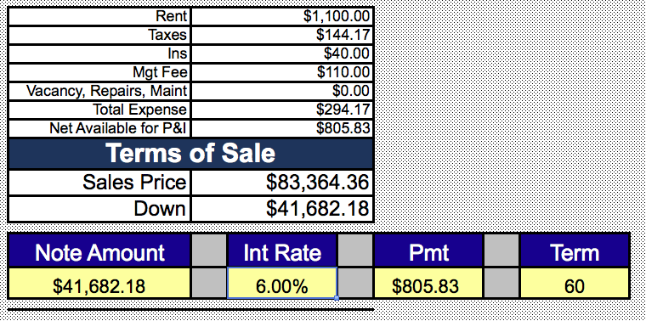

Supporting docs attached: 50/50 calc, Risk report, Partial agreement, BPO

**Kevin Moen**

**Mortgage delinquencies among some homeowners just spiked, spelling trouble - CNBC**

[**http://www.cnbc.com/2017/02/15/mortgage-delinquencies-among-some-homeowners-just-spiked-spelling-trouble.html**](http://www.cnbc.com/2017/02/15/mortgage-delinquencies-among-some-homeowners-just-spiked-spelling-trouble.html)

**2017 Titanium Visits**

Titanium Office Visit – April 10th – 12th

Titanium Office Visit – June 19th – 21st

Titanium Office Visit – July 17th – 19th

Titanium Office Visit – August 14th – 16th

Titanium Office Visit – September 18th – 20th

Titanium Office Visit – October 9th – 11th

**Hold June 2nd and 3rd for the Summer Summit**

**DSnews – Here is How to Find Market Deficiencies (Written by - Eddie Speed)**

[**http://www.dsnews.com/daily-dose/01-16-2017/find-market-deficiencies**](http://www.dsnews.com/daily-dose/01-16-2017/find-market-deficiencies)

**New email for Content Docs Submissions**

<https://www.dropbox.com/request/Enk7QksdLwgqXgVMK2Bz>

**New email for closing issues** (Includes request for any missing executed post-closing docs)

[**PostClosing**@colonialfundinggroup.com](mailto:PostClosing@colonialfundinggroup.com)

**If you want to Purchase Assets from the call:** [**Offering@colonialfundinggroup.com**](mailto:Offering@colonialfundinggroup.com)

**Please Submit Questions to:** [**Content@noteschool.com**](mailto:Content@noteschool.com)

**To Buy a Partial Contact Martha Speed at** [**Martha@noteschool.com**](mailto:Martha@noteschool.com)