

# Topics Covered:

**Deborah K:** Architecting a Deal

**Dave Franeki:** Purchasing a Re-performing Note Being Discharged from BK13

**Sara Krapitz:** Return on Investment

**NotesDirect:** Reminders

**NotesExpo:** Register for Event and Hotel Reservations

**Questions for the experts:**

1. We are trying to learn how to analyze properties to architect deals.  Below are details on one we own free and clear.  We had a tenant approach us and wants to buy it - **$10K** Down can afford **$800/mo**.

**EXECUTIVE SUMMARY**

Loan Type: Currently a rental

Property Address: 658 Richard Browning Way Knoxville, TN 37920

Current Value: $120,000

Average Rent: $800.00

Asking price: $115,000

Property Type:walk out basement ranch

Bath: 2

SQ FT: 1320

Acreage: 1.00

Amount of Taxes Due: $470.38

Current Status:Paid

Liens: none

**Deborah Krajnc**

1. I am reviewing a re-performing Chapter 13 BK mtg in VA.  It was recently confirmed.

**QUESTIONS:**

* Payer’s ability to repay as shown on pages 7-11 of the BK Plan-- income/expense projections—seem very skinny and doomed for failure if there is a hic-up in income (not much there). His monthly gross is from a small maintenance job and rental property income--$2406. If DTI is 21% based on the monthly note and arrearage payments.
* What if he fails to perform?
* The original note rate was 14.5%, but per the plan reduced to 13.55%--
* The arrearage account of $14,991 is to be paid of interest free in one of 2 ways—LACKING VERIFICATION OF THIS, just verbal and may be reconfirmed with 2 options. Of the $335 monthly amount due on the arrearage, the following pertains to the note payment
  + 43 months @$275/mo
  + 60 months @ $197/mo
* The seller is asking $24,500+/- based on $32,094.05 owed for the purchase price of the note and the arrearage account—about a 24% discount. How would you calculate the yield based on fact there is no interest on the arrearage account and 13.55% on the note—breakdown on executive summary.
  + If prorated between the 2 @76%
  + UPB                        $13,059
  + Arrearage account $11,730
* What is a good price to pay?

I have limited experience in BK notes and would welcome your input. Would you do this deal?

**Dave**

1. I have an investor that I am looking at brokering a note to and the investor is overall very intelligent, but not in the money arena whatsoever.  So, showing him a 10% yield doesn't mean much, but he does seem to be impacted by actual dollar figures.  I want to make sure I am not misrepresenting the asset if I present it to him in dollars instead of return rate. I feel like the following chart makes sense but want to make sure I'm not missing something.

|  |  |  |  |  |  |  |  |  |  |
| --- | --- | --- | --- | --- | --- | --- | --- | --- | --- |
| **Gross Monthly P&I Payment** | **Payments Remaining** | **Corresponding Years** | **Overall Gross Income** |  | **Purchase Price** |  | **Overall Profit** |  | **Income Per Year** |
| $877 | 300 | 25.00 | $263,049.81 |  | $96,000 |  | $167,050 |  | $6,681.99 |
|  |  |  |  |  |  |  |  |  |  |
|  |  |  |  |  |  |  |  |  |  |
| **If loan pays off after # years** | **Gross Income from Payments** | **Principal Payoff** | **Less Investment** |  | **Overall Profit** |  |  |  |  |
| 1 | $6,682 | $96,495.01 | $(96,000) |  | $7,177 |  |  |  |  |
| 2 | $13,364 | $95,571.33 | $(96,000) |  | $12,935 |  |  |  |  |
| 3 | $20,046 | $94,551.04 | $(96,000) |  | $18,597 |  |  |  |  |
| 4 | $26,728 | $93,424.02 | $(96,000) |  | $24,152 |  |  |  |  |
| 5 | $33,410 | $92,179.11 | $(96,000) |  | $29,589 |  |  |  |  |
| 6 | $40,092 | $90,803.98 | $(96,000) |  | $34,896 |  |  |  |  |
| 7 | $46,774 | $89,285.00 | $(96,000) |  | $40,059 |  |  |  |  |
| 8 | $53,456 | $87,607.14 | $(96,000) |  | $45,063 |  |  |  |  |
| 9 | $60,138 | $85,753.76 | $(96,000) |  | $49,892 |  |  |  |  |

**Sara Kranpitz**

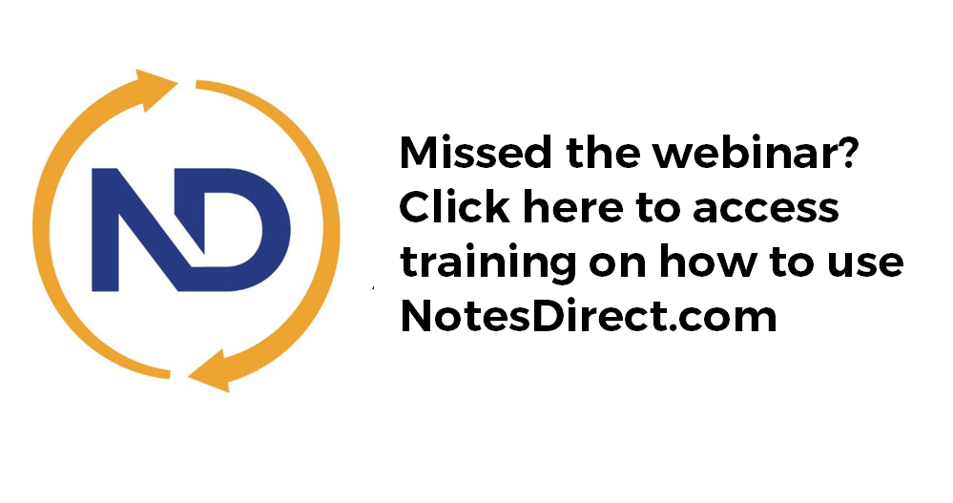

**NotesDirect Reminders**

* NoteDirect is designed to be used with Google Chrome
* Training videos available on the website
* New assets only available through NotesDirect; spreadsheet “Tape” has been eliminated

**5th Annual Appreciation Event and NoteExpo**

**Fort Worth, Texas**

**Highlights from Tentative Agenda**

Wednesday, November 2nd: Titanium Members VIP Event & Reception 5:30 - 7:30pm

Thursday, November 3rd: 5th Annual Appreciation Event 8:30am - 5:30pm

NoteSchool’s 5th Annual Appreciation Reception 6:30 – 7pm

NoteSchool’s 5th Annual Appreciation Dinner

NoteSchool’s 5th Annual Live Charity Auction

Friday, November 4: NoteExpo 2016 – Day One 8:30am - 5:30pm

NoteExpo Welcome Reception 5:30pm – 7:00pm

Saturday, November 5: NoteExpo 2016 – Day Two 8:30am - 4:30pm

**Event Registration:** <http://tinyurl.com/2016Apprec>

**Hotel Registration**

We have negotiated a discounted room rate of $169.00 to $199.00 per night at the Sheraton Forth Worth Hotel and Spa, 1701 Commerce St, Fort Worth, TX 76102. This rate is only available if you book your room by October 17, 2016. You can reserve your room by calling 817-335-7000 or by clicking the following link: <https://www.starwoodmeeting.com/events/start.action?id=1607140564&key=AD2757B>

**New email for Content Docs Submissions**

<https://www.dropbox.com/request/Enk7QksdLwgqXgVMK2Bz>

**New email for closing issues** (Includes request for any missing executed post-closing docs)

[**PostClosing**@colonialfundinggroup.com](mailto:PostClosing@colonialfundinggroup.com)

**If you want to Purchase Assets from the call:** [**Offering@colonialfundinggroup.com**](mailto:Offering@colonialfundinggroup.com)

**Please Submit Questions to:** [**Content@noteschool.com**](mailto:Content@noteschool.com)

**To Buy a Partial Contact Martha Speed at** [**Martha@noteschool.com**](mailto:Martha@noteschool.com)