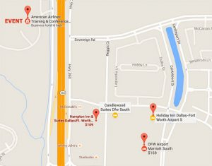

Event Location:

**American Airlines Conference Center**  
4501 Highway 360 South MD 929  
Fort Worth, TX 76155

**Hotel Phone: 817-956-1000**

**Room are sold out. Below are other locations across the highway from the event center. They have stated they will provide shuttle service to and from the event center.**

Hampton Inn & Suites Dallas AssFt. Worth Airport South  
4201 Reggis Ct, Fort Worth, TX 76155  
*Will provide shuttle; est. room rate $149.00+  
[hamptoninn3.hilton.com](http://www.hamptoninn3.hilton.com) (817) 952-3080

Holiday Inn Dallas-Fort Worth Airport South  
14320 Center Station Dr, Fort Worth, TX 76155  
*Will provide shuttle; est. room rate $158.00  
[ihg.com](http://www.ihg.com) (817) 399-1800

Candlewood Suites Dfw South  
4200 Reggis Ct, Fort Worth, TX 76155  
*Will provide shuttle est. room rate $125.00  
[ihg.com](http://www.ihg.com) (817) 868-1900

DFW Airport Marriott South  
4151 Centreport Dr, Fort Worth, TX 76155  
*Will provide shuttle est. room rate $209.00  
[marriott.com](http://www.marriott.com) (817) 358-1700